Entity Framework Core
Talking to CareBridgeDB with C# instead of SQL
Day 4 - Building Data-Driven Applications with EF Core

HCA Healthcare India · Enterprise .NET & C# Developer Track
.NET 8 · Visual Studio 2022 · SQL Server 2022 · SSMS
Built entirely on the CareBridgeDB database you created on Day 2.

# | Module | What students DO
1 | ORM Foundations | See the problem ORM solves, map class↔table on paper
2 | First EF Core Project | Create project, install packages, write model classes
3 | DbContext | Build the context; understand DbSet & SaveChanges
4 | Database-First (Scaffold) | Reverse-engineer CareBridgeDB into C# automatically
5 | CRUD Operations | Insert, read, update, delete a patient - live
6 | LINQ Fundamentals | Seven real healthcare queries, explained line by line
7 | Mini App: Patient Lookup | Build a working console app end to end
8 | Frontend Awareness + tiny demo | See how Vue → API → EF → SQL fit, run a tiny demo

Module 1 - ORM Foundations

What is an ORM?
ORM stands for Object-Relational Mapper. Break the name apart and it explains itself. ‘Object’ is a C# object - an instance of a class, living in memory. ‘Relational’ is the relational database - tables, rows, and columns in SQL Server. ‘Mapper’ is the translator that connects the two. An ORM lets you work with database data as ordinary C# objects, and it writes the SQL for you behind the scenes.
Concretely: instead of writing a SQL query, sending it to the database, and manually copying each column into variables, you write something like db.Patients.Find(1) and get back a Patient object with its properties already filled in. The ORM generated the SQL, ran it, and built the object for you.
FROM YOUR BACKGROUND (C++ / Java / Python)
If you used Hibernate/JPA in Java or SQLAlchemy/Django in Python, you have already done this. EF Core is exactly that idea for C# and .NET. The vocabulary differs, the concept is identical - classes stand in for tables, objects stand in for rows.

The problem ORM solves - raw SQL everywhere
Imagine reading one patient from the database using the old, manual way. Even for a single row it is verbose, repetitive, and fragile.
1 // The OLD way: raw ADO.NET. Lots of plumbing for ONE patient.
2 using var conn = new SqlConnection(connectionString);
3 conn.Open();
4 var cmd = new SqlCommand("SELECT PatientId, FullName, City FROM Patient WHERE PatientId = @id", conn);
5 cmd.Parameters.AddWithValue("@id", 1);
6 using var reader = cmd.ExecuteReader();
7 Patient p = null;
8 if (reader.Read())
9 {
10 p = new Patient();
11 p.PatientId = reader.GetInt32(0); // copy column 0 by hand
12 p.FullName = reader.GetString(1); // copy column 1 by hand
13 p.City = reader.GetString(2); // copy column 2 by hand
14 }
15 // ...and you repeat this plumbing for EVERY query in the whole app.
Now the same thing with EF Core. One line. The ORM writes the SQL and fills the object:
1 // The NEW way with EF Core: one readable line.
2 Patient p = db.Patients.Find(1); // EF writes the SQL and builds the object
The pain of the first version - the repetition, the by-hand column copying, the risk of a typo in a SQL string - is exactly what an ORM removes.

The three mappings (the heart of ORM)
An ORM rests on three simple correspondences.
In the database (Day 2) | In C# (today) | Example from CareBridge
Table | Class | The Patient table ↔ a Patient class
Column | Property | FullName column ↔ FullName property
Row | Object | One patient's row ↔ one Patient object
That is the whole mental model. A class is a table. A property is a column. An object is a row. Everything in EF Core is built on these three lines.

Module 2 - Your First EF Core Project
Everyone builds the project together, click by click. Project name: CareBridge.EFCoreDemo.
Why this matters
Before EF Core can do anything, three things must exist: a project to hold the code, the EF Core packages installed into it, and C# classes that mirror the tables. We create all three now, slowly, so nobody is lost. No step is assumed.
Live Demonstration (instructor screen)

Step 1 - Create the project
1. Open Visual Studio 2022. On the start screen click Create a new project.
2. In the search box type Console. Select Console App (the C# one, with the .NET logo) - not ‘Console App (.NET Framework)’. Click Next.
3. Project name: CareBridge.EFCoreDemo. Location: C:\<YourName>\. Click Next.
4. Framework: choose .NET 8.0 (Long Term Support). Click Create.
5. Visual Studio opens Program.cs with one line: Console.WriteLine("Hello, World!");.
Live Demonstration

Step 2 - Install the EF Core NuGet packages
A NuGet package is a reusable library someone else wrote that you add to your project - the same idea as a Maven dependency, a pip package, or a vcpkg library. EF Core ships as NuGet packages. Install them through the console:
1. Open Tools → NuGet Package Manager → Package Manager Console.
2. Type these three commands, one at a time, pressing Enter after each:
1 Install-Package Microsoft.EntityFrameworkCore.SqlServer -Version 8.0.*
2 Install-Package Microsoft.EntityFrameworkCore.Design -Version 8.0.*
3 Install-Package Microsoft.EntityFrameworkCore.Tools -Version 8.0.*
In one sentence each: SqlServer teaches EF Core how to talk to SQL Server specifically; Design and Tools provide the commands we will use in Module 4 to read the existing database.
Live Demonstration

Step 3 - Create a folder for the model classes
1. In Solution Explorer (right side), right-click the project name CareBridge.EFCoreDemo.
2. Choose Add → New Folder. Name it Models.
3. This folder will hold one class per table - keeping classes organised, exactly like a models/ package in Java or Python.

Step 4 - Write the four model classes
Right-click the Models folder → Add → Class, name it Patient.cs, and paste the code below. Repeat for Provider, Department, and Encounter. Every property maps to a Day-2 column.
Hands-On
// Models/Patient.cs
namespace CareBridge.EFCoreDemo.Models;

public class Patient
{
public int PatientId { get; set; } // PatientId column (primary key)
public string Mrn { get; set; } = ""; // MRN column (unique per patient)
public string FullName { get; set; } = ""; // FullName column
public DateOnly DateOfBirth { get; set; } // DateOfBirth column (DATE)
public char Gender { get; set; } // Gender column ('M','F','O')
public string? City { get; set; } // City column (can be empty)
public bool IsActive { get; set; } // IsActive column (1/0 -> true/false)
}

// Models/Provider.cs
namespace CareBridge.EFCoreDemo.Models;

public class Provider
{
public int ProviderId { get; set; } // ProviderId column (primary key)
public string FullName { get; set; } = ""; // FullName column (e.g. 'Dr. Maya Patel')
public string Specialty { get; set; } = ""; // Specialty column
public int DepartmentId { get; set; } // DepartmentId column (FK)
}

// Models/Department.cs
namespace CareBridge.EFCoreDemo.Models;

public class Department
{
public int DepartmentId { get; set; } // DepartmentId column (primary key)
public string Name { get; set; } = ""; // Name column (e.g. 'Cardiology')
public string? Location { get; set; } // Location column
}

// Models/Encounter.cs
namespace CareBridge.EFCoreDemo.Models;

public class Encounter
{
public int EncounterId { get; set; } // EncounterId column (primary key)
public int PatientId { get; set; } // PatientId column (FK -> Patient)
public int ProviderId { get; set; } // ProviderId column (FK -> Provider)
public int DepartmentId { get; set; } // DepartmentId column (FK -> Department)
public DateTime AdmitDate { get; set; } // AdmitDate column (DATETIME2)
public DateTime? DischargeDate { get; set; } // DischargeDate column (can be empty)
public string EncounterType { get; set; } = ""; // 'Inpatient' / 'Outpatient' / 'ED'
}
Expected Output
The project builds with no errors (Build → Build Solution, or Ctrl+Shift+B). Four classes sit inside the Models folder. Nothing talks to the database yet - that is Module 3. Right now we have only described the shape of our data in C#.

Module 3 - The DbContext: Your Door to the Database
one new class, three big ideas (DbSet, change tracking, SaveChanges).
Why this matters
The model classes from Module 2 describe data shapes, but they cannot reach the database on their own. EF Core needs one special class that knows the connection and lists which tables you want to work with. That class is the DbContext. Think of it as the single door through which all your data goes in and out.

What a DbContext is
A DbContext is a C# class you write that inherits from EF Core's DbContext base class. It does two jobs. First, it holds the connection string - the address and credentials that tell EF Core which SQL Server and which database to talk to (here, CareBridgeDB). Second, it exposes one DbSet<T> property per table you want to use. A DbSet<Patient> represents the whole Patient table, and you query and modify it like a collection.

What a connection string is
A connection string is just a line of text describing how to reach the database: which server, which database, and how to authenticate. Ours points at the local SQL Server and the CareBridgeDB the class built on Day 2.
Server=localhost;Database=CareBridgeDB;Trusted_Connection=True;TrustServerCertificate=True

// Server=localhost -> SQL Server is on this machine
// Database=CareBridgeDB -> the Day-2 hospital database
// Trusted_Connection=True -> log in with your Windows account (no password in text)
// TrustServerCertificate -> accept the local dev certificate (dev machines only)
Live Demonstration (instructor screen)

Step 1 - Create the DbContext class
Right-click the project → Add → New Folder → name it Data. Right-click Data → Add → Class → name it CareBridgeContext.cs. Paste:
using Microsoft.EntityFrameworkCore; // Contains DbContext, DbSet, ModelBuilder, etc.
using CareBridge.EFCoreDemo.Models; // Gives access to Patient, Provider, Department, Encounter classes

namespace CareBridge.EFCoreDemo.Data; // Organizes database-related classes under the Data folder

// DbContext is the heart of EF Core.
// It represents a session/connection with the database.
public class CareBridgeContext : DbContext
{
// Each DbSet represents a table in SQL Server.
// EF Core uses these properties to query and save data.

public DbSet<Patient> Patients { get; set; } // Maps to Patient table
public DbSet<Provider> Providers { get; set; } // Maps to Provider table
public DbSet<Department> Departments { get; set; } // Maps to Department table
public DbSet<Encounter> Encounters { get; set; } // Maps to Encounter table

// OnConfiguring() is a built-in DbContext method.
// We override it to tell EF Core:
// 1. Which database provider to use (SQL Server)
// 2. Which database to connect to
protected override void OnConfiguring(DbContextOptionsBuilder options)
{
options.UseSqlServer(
"Server=localhost;Database=CareBridgeDB;" +
"Trusted_Connection=True;TrustServerCertificate=True");
}

// OnModelCreating() runs when EF Core builds its internal model.
// We use it to customize mappings between C# classes and SQL tables.
protected override void OnModelCreating(ModelBuilder modelBuilder)
{
// By default EF Core may use naming conventions.
// Here we explicitly map each class to its existing SQL table.

modelBuilder.Entity<Patient>().ToTable("Patient"); // Patient class -> Patient table
modelBuilder.Entity<Provider>().ToTable("Provider"); // Provider class -> Provider table
modelBuilder.Entity<Department>().ToTable("Department"); // Department class -> Department table
modelBuilder.Entity<Encounter>().ToTable("Encounter"); // Encounter class -> Encounter table
}
}

The three ideas inside the DbContext
The three behaviors the class quietly provides. We will use all three in Module 5.
Idea | In plain language
DbSet<T> | A live, queryable stand-in for a table. db.Patients IS the Patient table. You read from it and add to it like a collection.
Change Tracking | While the context is open, EF Core quietly watches every object it gave you. If you change a patient's City, it remembers that one change - so it knows exactly what UPDATE to write later.
SaveChanges() | The moment you say ‘now write it.’ EF Core looks at everything that changed (adds, edits, deletes) and sends the right INSERT / UPDATE / DELETE statements in one go.
FROM YOUR BACKGROUND (C++ / Java / Python)
Change tracking is a surprise. You do not write UPDATE. You load an object, change a property, and call SaveChanges() - EF figured out what changed.
Hands-On
Prove the door opens. In Program.cs, replace the Hello World line with a tiny connection test and run with Ctrl+F5:
// Program.cs
using CareBridge.EFCoreDemo.Data;

// Create a DbContext object.
// DbContext represents a session with the database.
// It manages connections, queries, tracking, and saving changes.
using var db = new CareBridgeContext();

// Count() is a LINQ aggregate method.
// EF Core translates this C# code into SQL and executes it on SQL Server.
// Roughly equivalent SQL:
// SELECT COUNT(*) FROM dbo.Patient
int patientCount = db.Patients.Count();

// Display the result on the console.
Console.WriteLine($"CareBridgeDB has {patientCount} patients.");
Expected Output
CareBridgeDB has 1000 patients.



That number is the Day-2 seed data, reached from C# with zero hand-written SQL.

Module 4 - Database-First: Let EF Read CareBridgeDB For You
one command does what Module 2 did by hand - for the WHOLE database.
Why this matters
In Module 2 the class wrote four model classes by hand. But CareBridgeDB has eight tables, with keys and relationships. Writing all of that by hand is slow and error-prone.
EF Core can read an existing database and generate every class and the DbContext for you. This is called the database-first approach, and the action is called scaffolding (Auto-generate classes from the database).

What ‘reverse engineering’ means
Normally you might design classes first and let EF create tables. Here we go the other way: the tables already exist (the class built them on Day 2), so EF inspects them - their columns, types, primary keys, and foreign keys - and writes matching C# automatically. Reading a finished database backwards into code is why it's called reverse engineering.
FROM YOUR BACKGROUND (C++ / Java / Python)
Java's JPA tools and Python's sqlacodegen / Django’s inspectdb do the same job
Live Demonstration

Step 1 - Run the scaffold command
Open Tools → NuGet Package Manager → Package Manager Console and run the command below. It is one physical line; the parts are explained underneath.
Scaffold-DbContext "Server=localhost;Database=CareBridgeDB;Trusted_Connection=True;TrustServerCertificate=True" Microsoft.EntityFrameworkCore.SqlServer -OutputDir Models/Generated -Context CareBridgeScaffoldContext -Force
Part of the command | What it does
"Server=...CareBridgeDB..." | The connection string - which database to read.
Microsoft.EntityFrameworkCore.SqlServer | Use the SQL Server provider to read it.
-OutputDir Models/Generated | Put the generated classes in this folder.
-Context CareBridgeScaffoldContext | Name the generated DbContext class.
-Force | Overwrite previous generated files if you run it again.
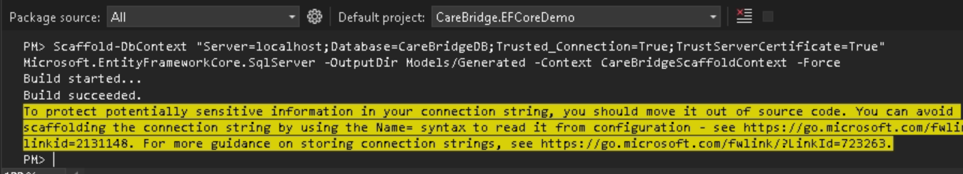
Expected Output
A new folder Models/Generated appears containing one class per table - Patient, Provider, Department, Encounter, Diagnosis, Procedure, Insurance, Claim - plus CareBridgeScaffoldContext.cs. Open the generated Patient.cs and notice EF discovered the relationships: it added navigation properties such as a list of Encounters, because it read the foreign keys.
1 Build started...
2 Build succeeded.
3 // Generated: Patient, Provider, Department, Encounter,
4 // Diagnosis, Procedure, Insurance, Claim + CareBridgeScaffoldContext
IMPORTANT - avoid the duplicate-class trap
You now have two sets of classes: the four you hand-wrote in Module 2 (in Models/) and the eight EF just generated (in Models/Generated/). Two classes named Patient will collide. For the rest of today we use the GENERATED set - it is complete and matches the database exactly. Either delete the four hand-written files from Module 2, or keep them only as a teaching artifact and do not reference them.

The hand-written exercise existed to teach the mapping; the generated set is what we build on.

Why this matters

Imagine a hospital database with 300 tables.

Writing 300 model classes manually would take days and mistakes are inevitable.

Scaffolding allows EF Core to inspect the database and generate classes automatically.

Benefits:
• Saves development time
• Reduces human errors
• Keeps code aligned with database structure
• Useful when the database already exists

Real-world use:
Most enterprise projects start with an existing database, making Database-First a very common approach.

Module 5 - CRUD: Insert, Read, Update, Delete a Patient
We will run all four operations against CareBridgeDB.
Why this matters
CRUD stands for Create, Read, Update, Delete - the four things every application does with data. Once you do CRUD with EF Core, you can build almost anything. We do all four on the Patient table, using the generated classes from Module 4, and we watch EF write the SQL for us.
Note on the generated context: in Module 4 we named it CareBridgeScaffoldContext. Use that name below. (If your generated context exposes the patients set as Patients, the code matches as written.)

C - Create (Insert a new patient)
Live Demonstration
To add a row, you create a C# object, add it to the DbSet, and call SaveChanges. EF generates the INSERT and - because PatientId is an identity column - fills the new id back into your object automatically.
Program.cs:
using CareBridge.EFCoreDemo.Models.Generated;

using var db = new CareBridgeScaffoldContext();

var newPatient = new Patient
{
Mrn = "MRN900001",
FullName = "Ananya Sharma",
DateOfBirth = new DateOnly(1990, 5, 14),
Gender = "F",
City = "Hyderabad",
IsActive = true
};

db.Patients.Add(newPatient);
db.SaveChanges();

Console.WriteLine($"Inserted patient with new Id = {newPatient.PatientId}");
Expected Output
Inserted patient with new Id = 1001



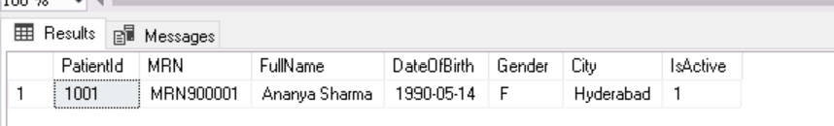

R - Read (Find and list patients)
Live Demonstration (instructor screen)
Reading is the most common operation. Find gets one row by primary key; a foreach over the DbSet reads many. EF turns both into SELECT statements.
Program.cs:
using CareBridge.EFCoreDemo.Models.Generated; // Generated Patient, Provider, Encounter classes

// Create a DbContext object.
// DbContext represents a session with the database.
// Through this object we can query and modify database tables.
using var db = new CareBridgeScaffoldContext();

// ---------------------------
// READ ONE PATIENT
// ---------------------------

// Find() searches using the primary key (PatientId).
// EF Core generates SQL similar to:
// SELECT * FROM Patient WHERE PatientId = 1

var p = db.Patients.Find(1);

if (p != null)
{
Console.WriteLine($"{p.PatientId}: {p.FullName} ({p.City})");
}
else
{
Console.WriteLine("Patient not found.");
}

// ---------------------------
// READ MULTIPLE PATIENTS
// ---------------------------

// Take(5) limits the result to the first 5 rows.
// Similar SQL:
// SELECT TOP 5 * FROM Patient

foreach (var patient in db.Patients.Take(5))
{
Console.WriteLine($"{patient.PatientId} - {patient.FullName}");
}
Expected Output
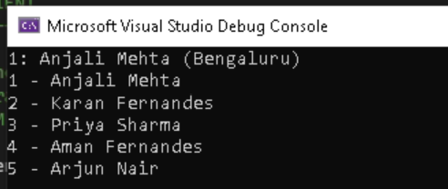

U - Update (Change a patient, let EF detect it)
Live Demonstration (instructor screen)
This is where change tracking shines. You load a patient, change a property, and call SaveChanges. You never write UPDATE - EF compares the object to what it loaded and writes only what changed.
using CareBridge.EFCoreDemo.Models.Generated; // Generated Patient, Provider, Encounter classes

// Create a DbContext object.
// DbContext represents a session with the database.
// EF Core uses this object to query and update data.
using var db = new CareBridgeScaffoldContext();

// ---------------------------
// UPDATE A PATIENT
// ---------------------------

// Step 1: Load a patient from the database.
// Find() searches using the primary key (PatientId).
//
// EF Core generates SQL similar to:
// SELECT * FROM Patient WHERE PatientId = 1
var patient = db.Patients.Find(1);

// Always check whether a record was found.
if (patient != null)
{
// Step 2: Modify a property in memory.
// This is just a normal C# property assignment.
// EF Core is tracking this object and notices the change.
patient.City = "Bengaluru";

// Step 3: Save the changes.
// EF Core compares the current object with the original values
// it loaded from the database.
//
// EF Core generates SQL similar to:
// UPDATE Patient
// SET City = 'Bengaluru'
// WHERE PatientId = 1
db.SaveChanges();

Console.WriteLine($"Patient 1 city is now {patient.City}");
}
else
{
Console.WriteLine("Patient not found.");
}
Expected Output

FROM YOUR BACKGROUND (C++ / Java / Python)
The interesting part is that we never write UPDATE SQL. We load a patient object, change one of its properties, and call SaveChanges(). EF Core figures out what changed and updates the database automatically.

D - Delete (Remove a patient)
Live Demonstration (instructor screen)
To delete, load the row, mark it for removal, and save. EF writes the DELETE. (We delete the test patient we created, not a real one.)
using CareBridge.EFCoreDemo.Models.Generated; // Generated Patient, Provider, Encounter classes

// Create a DbContext object.
// DbContext represents a session with the database.
// EF Core uses this object to query and modify data.
using var db = new CareBridgeScaffoldContext();

// ---------------------------
// DELETE A PATIENT
// ---------------------------

// Step 1: Find the patient we inserted earlier.
// We search using the unique MRN value.
//
// FirstOrDefault() returns:
// - the first matching patient if found
// - null if no matching patient exists
//
// EF Core generates SQL similar to:
// SELECT * FROM Patient WHERE MRN = 'MRN900001'

var toDelete = db.Patients.FirstOrDefault(p => p.Mrn == "MRN900001");

// Step 2: Check whether the patient was found.
if (toDelete != null)
{
// Step 3: Mark the object for deletion.
// The row is NOT deleted yet.
db.Patients.Remove(toDelete);

// Step 4: SaveChanges() sends the DELETE command to SQL Server.
//
// EF Core generates SQL similar to:
// DELETE FROM Patient
// WHERE PatientId = ...
db.SaveChanges();

Console.WriteLine("Test patient deleted successfully.");
}
else
{
Console.WriteLine("Patient not found.");
}
Expected Output


What EF Core Does Behind The Scenes

When developers write: db.Patients.Add(patient);

EF Core does not immediately talk to SQL Server.

It first tracks changes in memory.
Only when SaveChanges() is called does EF Core generate SQL commands and send them to the database.

Think of SaveChanges() as the Commit button. Without SaveChanges(), nothing is written to SQL Server.

Module 6 - LINQ: Querying in C# Instead of SQL
Seven real healthcare queries
Why this matters
LINQ stands for Language Integrated Query. It lets you write queries directly in C# - filtering, sorting, joining, grouping - and EF Core translates each one into SQL for you.
FROM YOUR BACKGROUND (C++ / Java / Python)
LINQ is close to Java Streams (.filter().map().collect()) and Python list comprehensions / filter(). If a student knows stream().filter(p -> p.active) in Java, then Where(p => p.IsActive) in C# is the same thought. The => is a lambda, just like Java’s ->.

Before we start writing queries, there are two small concepts to understand.

1. Lambda Expression (=>)

A lambda is just a short way of writing a condition.

Example: p => p.City == "Pune"

Read it as: "For each patient p, check whether the patient's city is Pune."

Here:

p = one Patient object

p.City = the City property of that patient

== = compare

"Pune" = the value we are looking for

Think of it like asking: "Is this patient from Pune?"

If yes, keep the patient.

If no, skip the patient.

2. ToList()

When we write a query, EF Core does not immediately go to the database.

For example: var patients = db.Patients.Where(p => p.City == "Pune");

At this point, EF Core is only preparing the query. No SQL has been executed yet.

The query actually runs when we ask for the results, such as:

ToList()

First()

FirstOrDefault()

Count()

Any()

Example:

var patients = db.Patients

.Where(p => p.City == "Pune")

.ToList();

Now EF Core sends a SQL query to SQL Server and brings back the matching rows.

How LINQ Works

Developers write LINQ. EF Core translates LINQ into SQL. SQL Server executes SQL.

Results are returned as C# objects.

Example:
LINQ:
db.Patients.Where(p => p.City == "Pune")

Generated SQL:
SELECT *
FROM Patient
WHERE City = 'Pune'

This allows developers to stay inside C# while still leveraging the power of SQL Server.

Module 7 - Mini App: CareBridge Patient Lookup System
Why this matters
Now we assemble the pieces into something that feels like a real tool. The CareBridge Patient Lookup System is a menu-driven console app a ward clerk could actually use: list patients, search by MRN, view a patient's encounters, view claims. It uses the generated EF Core classes and the LINQ from Module 6.

The complete program
Replace everything in Program.cs with the code below.
using CareBridge.EFCoreDemo.Models.Generated;

// Create a DbContext object.
// DbContext represents a session/connection with the database.
// Through this object we can query and modify data in CareBridgeDB.
using var db = new CareBridgeScaffoldContext();

while (true)
{
Console.Clear();

Console.WriteLine("=================================");
Console.WriteLine(" LINQ QUERY DEMO");
Console.WriteLine("=================================");
Console.WriteLine("1. Get All Patients");
Console.WriteLine("2. Active Patients");
Console.WriteLine("3. Patients From Pune");
Console.WriteLine("4. Recent Encounters");
Console.WriteLine("5. Denied Claims");
Console.WriteLine("6. Join Patient + Encounter");
Console.WriteLine("7. Encounters By Department");
Console.WriteLine("8. Exit");
Console.WriteLine();

Console.Write("Choose an option (1-8): ");
string? choice = Console.ReadLine();

Console.WriteLine();

switch (choice)
{
case "1":

Console.WriteLine("===== QUERY 1 - ALL PATIENTS =====");

// db.Patients represents the Patient table.
// ToList() executes the query and fetches all rows.
//
// SQL Equivalent:
// SELECT * FROM Patient

var all = db.Patients.ToList();

Console.WriteLine($"Total patients: {all.Count}");

break;

case "2":

Console.WriteLine("===== QUERY 2 - ACTIVE PATIENTS =====");

// Where() is the LINQ equivalent of SQL WHERE.
//
// p => p.IsActive means:
// "For each patient p, keep only rows
// where IsActive is true."
//
// SQL Equivalent:
// SELECT * FROM Patient
// WHERE IsActive = 1

var active = db.Patients
.Where(p => p.IsActive)
.ToList();

Console.WriteLine($"Active patients: {active.Count}");

break;

case "3":

Console.WriteLine("===== QUERY 3 - PATIENTS FROM PUNE =====");

// Step 1: Filter only Pune patients.
// Step 2: Sort by FullName (A-Z).
// Step 3: Execute the query.
//
// SQL Equivalent:
// SELECT *
// FROM Patient
// WHERE City = 'Pune'
// ORDER BY FullName

var punePatients = db.Patients
.Where(p => p.City == "Pune")
.OrderBy(p => p.FullName)
.ToList();

foreach (var patient in punePatients)
{
Console.WriteLine(patient.FullName);
}

Console.WriteLine($"\nTotal patients from Pune: {punePatients.Count}");

break;

case "4":

Console.WriteLine("===== QUERY 4 - RECENT ENCOUNTERS =====");

// Create a date representing 30 days ago.
var cutoff = DateTime.Now.AddDays(-30);

// Keep only encounters whose AdmitDate
// is within the last 30 days.
//
// OrderByDescending() sorts newest first.
//
// SQL Equivalent:
// SELECT *
// FROM Encounter
// WHERE AdmitDate >= cutoff
// ORDER BY AdmitDate DESC

var recent = db.Encounters
.Where(e => e.AdmitDate >= cutoff)
.OrderByDescending(e => e.AdmitDate)
.ToList();

Console.WriteLine($"Encounters in last 30 days: {recent.Count}");

break;

case "5":

Console.WriteLine("===== QUERY 5 - DENIED CLAIMS =====");

// Filter only claims whose status is Denied.
//
// SQL Equivalent:
// SELECT *
// FROM Claim
// WHERE Status = 'Denied'

var denied = db.Claims
.Where(c => c.Status == "Denied")
.ToList();

// Sum() adds all BilledAmount values together.
//
// SQL Equivalent:
// SELECT SUM(BilledAmount)
// FROM Claim
// WHERE Status = 'Denied'

decimal lost = denied.Sum(c => c.BilledAmount);

Console.WriteLine(
$"Denied claims: {denied.Count}, billed total: {lost:C}");

break;

case "6":

Console.WriteLine("===== QUERY 6 - JOIN PATIENT + ENCOUNTER =====");

// JOIN combines rows from multiple tables.
//
// Here we join:
// Encounter table
// +
// Patient table
//
// Matching condition:
// Encounter.PatientId = Patient.PatientId
//
// SQL Equivalent:
//
// SELECT p.FullName,
// e.EncounterType,
// e.AdmitDate
// FROM Encounter e
// JOIN Patient p
// ON e.PatientId = p.PatientId

var joined =
(
from e in db.Encounters

join pat in db.Patients
on e.PatientId equals pat.PatientId

// Create a smaller result object.
// Similar to choosing specific columns in SQL.
select new
{
pat.FullName,
e.EncounterType,
e.AdmitDate
}
)
.Take(10) // Similar to SQL TOP 10
.ToList();

foreach (var row in joined)
{
Console.WriteLine(
$"{row.FullName} - {row.EncounterType} on {row.AdmitDate:d}");
}

break;

case "7":

Console.WriteLine("===== QUERY 7 - ENCOUNTERS BY DEPARTMENT =====");

// GroupBy() is the LINQ equivalent of SQL GROUP BY.
//
// SQL Equivalent:
//
// SELECT DepartmentId,
// COUNT(*)
// FROM Encounter
// GROUP BY DepartmentId

var byDept = db.Encounters

// Create one group per department
.GroupBy(e => e.DepartmentId)

// Create a result object for each group
.Select(g => new
{
DepartmentId = g.Key,

// Count rows in this group
Count = g.Count()
})

// Highest count first
.OrderByDescending(x => x.Count)

.ToList();

foreach (var row in byDept)
{
Console.WriteLine(
$"Department {row.DepartmentId}: {row.Count} encounters");
}

break;

case "8":

Console.WriteLine("Goodbye!");
return;

default:

Console.WriteLine("Please enter a number from 1 to 8.");
break;
}

Console.WriteLine();
Console.WriteLine("Press any key to continue...");
Console.ReadKey();
}

e = one Encounter
g = one Group of Encounters
x = one Result Row

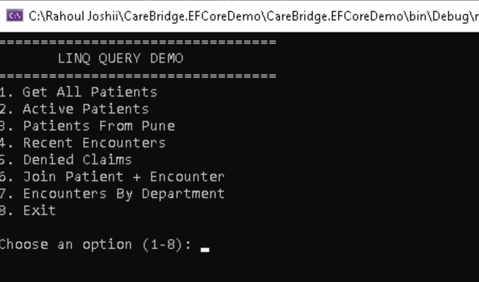

Module 8 - How the Frontend Fits (Awareness + a Tiny Demo)
This is not Vue.js in depth
Why this matters
The goal here is not to teach Vue - it is to remove the mystery: to show how the browser screen connects, step by step, all the way down to the CareBridgeDB rows they have been querying all day.

The four words, in plain language
Word | What it means
Frontend | What the user sees and clicks - the screen in the browser. Vue.js builds this.
Backend | The server-side program that holds the logic and talks to the database. Our .NET app, using EF Core.
Database | Where the data actually lives - SQL Server, holding CareBridgeDB.
API | The doorway between frontend and backend. The browser asks the API for data; the API answers.
JSON | The simple text format the API uses to send data - readable lists of name/value pairs, easy for the browser to use.

The architecture
1 Vue.js (the screen in the browser)
2 | asks for data over the internet (HTTP)
3 v
4 ASP.NET Core API (our backend doorway)
5 | uses
6 v
7 EF Core (today's learning: turns C# into SQL)
8 | talks to
9 v
10 SQL Server -> CareBridgeDB (the Day-2 tables)

The user opens a Vue page - Vue calls the API - the API uses EF Core (everything from today) to read CareBridgeDB - the data travels back up as JSON - Vue shows it on screen.
SQL Server

In a real application, users do not see SQL Server or EF Core. Users interact with a web page.

That web page calls an API. The API talks to EF Core. EF Core talks to SQL Server.

Architecture:
+------------------+
| Vue.js Frontend |
+------------------+
|
| HTTP Request
v
+------------------+
| ASP.NET Core API |
+------------------+
|
| LINQ
v
+------------------+
| EF Core |
+------------------+
|
| SQL
v
+------------------+
| SQL Server |
+------------------+
Goal is to show a simple Vue.js screen displaying Patient data from CareBridgeDB.

Starting Point
Your solution looks like this:
CareBridge.EFCoreDemo
│
├── Data
│ └── CareBridgeContext.cs
│
├── Models
│ ├── Generated
│ │ ├── CareBridgeScaffoldContext.cs
│ │ ├── Patient.cs
│ │ ├── Claim.cs
│ │ ├── Department.cs
│ │ ├── Diagnosis.cs
│ │ ├── Encounter.cs
│ │ ├── Insurance.cs
│ │ ├── Procedure.cs
│ │ ├── Provider.cs
│ │ └── VwClinical.cs
│ │
│ ├── Patient.cs
│ ├── Provider.cs
│ ├── Department.cs
│ └── Encounter.cs
│
└── Program.cs

Module 8 - Part 1
Create ASP.NET Core API Project
Step 1
Right Click Solution
Add → New Project
Choose: ASP.NET Core Web API
Click: Next

Step 2
Project Name: CareBridge.API
Click: Next

Step 3 - Additional Information
Select: Framework:
.NET 8.0 (LTS)
Authentication: None
Check:
✓ Configure for HTTPS
✓ Enable OpenAPI Support
✓ Use Controllers
Uncheck: ✗ Enable Container Support
✗ Enlist in Aspire
Click: Create

Module 8 - Part 2
Install Required Packages
Open: Tools
→ NuGet Package Manager
→ Package Manager Console
Select project:
CareBridge.API
Install EF Core SQL Server: Install-Package Microsoft.EntityFrameworkCore.SqlServer – 8.0.0
Install EF Core Tools: Install-Package Microsoft.EntityFrameworkCore.Tools – 8.0.0
Install Swagger: Install-Package Swashbuckle.AspNetCore – Current Version (update)

Swashbuckle.AspNetCore is used to automatically generate Swagger UI, which provides a web page to test and document our APIs.
Module 8 - Part 3
Copy Generated EF Core Classes
Inside:
CareBridge.EFCoreDemo
└── Models (Copy at this level)
└── Generated

Paste into:
CareBridge.API
Result:
CareBridge.API
└── Models
└── Generated

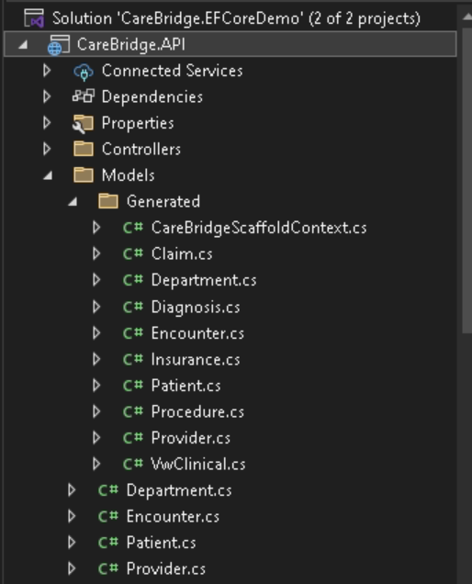

Module 8 - Part 4
Replace Program.cs
Open:
CareBridge.API
└── Program.cs

Delete everything.
Paste:

using CareBridge.EFCoreDemo.Models.Generated;
using Microsoft.EntityFrameworkCore;
var builder = WebApplication.CreateBuilder(args);
// Register EF Core DbContext.
// ASP.NET Core will automatically create and inject it when needed.
builder.Services.AddDbContext<CareBridgeScaffoldContext>();
// Add Swagger support.
// Swagger gives us a testing screen for APIs.
builder.Services.AddEndpointsApiExplorer();
builder.Services.AddSwaggerGen();
// Allow Vue.js running on another port
// to call this API from the browser.
builder.Services.AddCors(options =>
{
options.AddDefaultPolicy(policy =>
{
policy.AllowAnyOrigin()
.AllowAnyHeader()
.AllowAnyMethod();
});
});
var app = builder.Build();
// Enable Swagger.
app.UseSwagger();
app.UseSwaggerUI();
// Enable CORS.
app.UseCors();
// Simple health-check endpoint.
app.MapGet("/", () =>
{
return "CareBridge API is running";
});
// Return first 20 patients.
// EF Core converts this LINQ query into SQL.
app.MapGet("/api/patients",
(CareBridgeScaffoldContext db) =>
{
return db.Patients
// Select only columns we need.
.Select(p => new
{
p.PatientId,
p.FullName,
p.City
})
// Return only first 20 rows.
.Take(20)
// Execute query.
.ToList();
});
app.Run();

Module 8 - Part 5 Set Startup Project
Right Click: CareBridge.API
Choose: Set As Startup Project
Project name becomes bold.

Module 8 - Part 6
Run API
Press: F5
You should see a console window: Now listening on:
https://localhost:7137
http://localhost:5113

Your port numbers may differ.
Keep this window open.

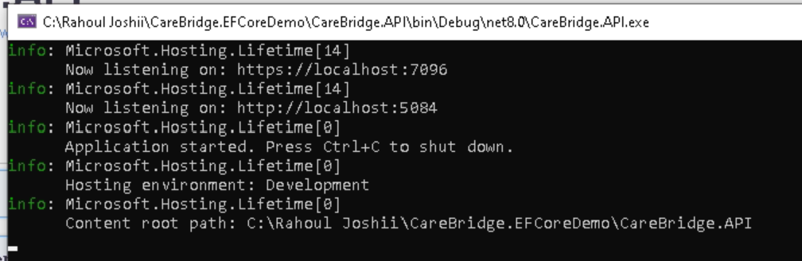

Module 8 - Part 7
Verify API Using Swagger
Open browser: https://localhost:7137/swagger (Remember port may differ)
Use your own port.
You should see:
GET /
GET /api/patients

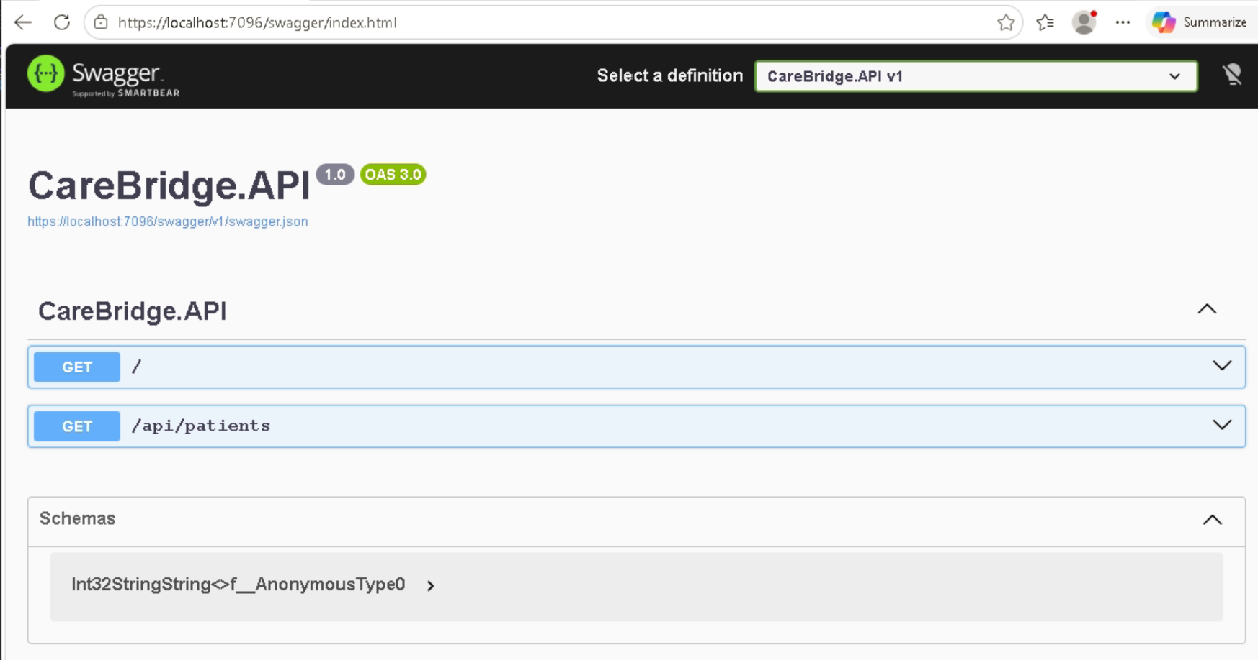

Test Endpoint
Expand: GET /api/patients
Click: Try it Out
Click: Execute
Expected:

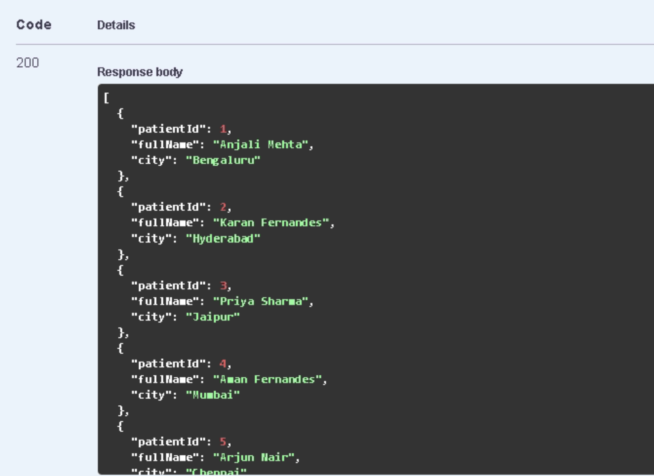

Theory
Swagger is simply a testing screen. Instead of writing code to call the API, Swagger calls it for us.
At this point you can verify:

Browser
↓
API
↓
EF Core
↓
SQL Server
is working.

Module 8 - Part 8
Install Node.js
Verify Node.js is installed.
Open terminal: (View Menu)
node -v
npm -v

Expected:
v22.x.x
10.x.x
Any recent version is fine.

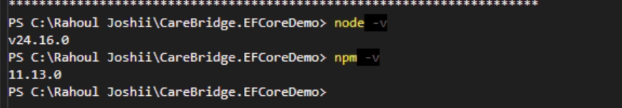

Module 8 - Part 9
Create Vue.js Project
Open terminal in solution folder.
Example: cd C:\Rahoul Joshii\CareBridge.EFCoreDemo
Create project:
npm create vite@latest carebridge-web -- --template vue

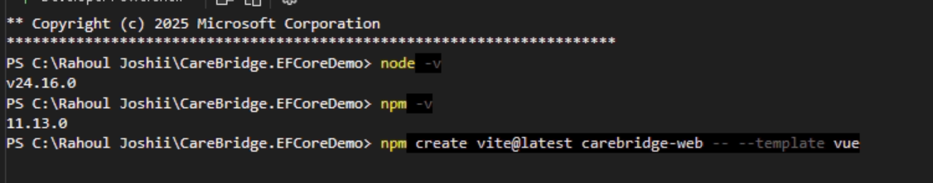

Select Yes

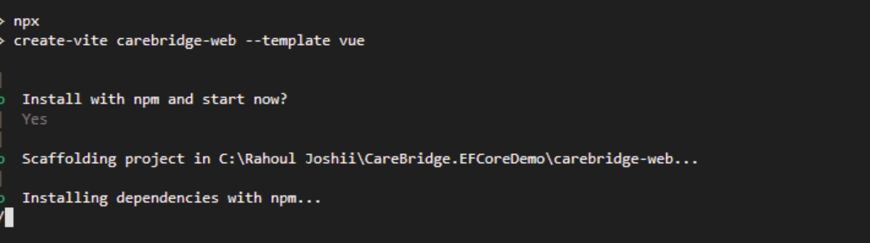

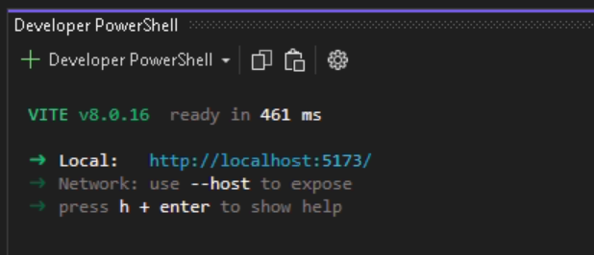
Module 8 - Part 10
Install Vue Packages
Move into project: cd carebridge-web
Install dependencies: npm install
Wait until installation completes.

Module 8 - Part 11
Run Vue
Run: npm run dev
Expected: VITE ready
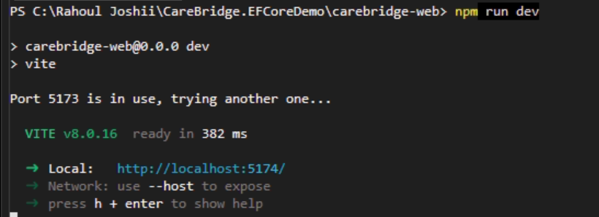
Local:
http://localhost:5173
Keep this terminal running.

Module 8 - Part 12
Open Vue Project in VS Code – use windows (command prompt)

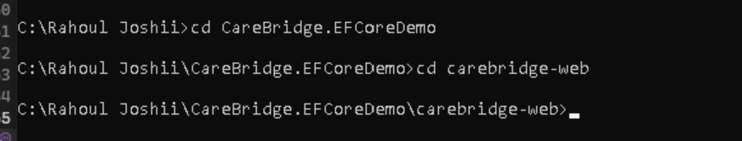

Open another terminal: cd carebridge-web
code .
VS Code opens.

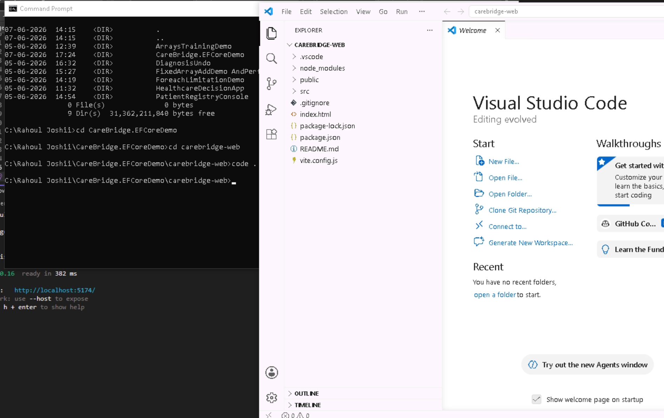

Module 8 - Part 13
Modify App.vue
Open:
src
└── App.vue

Delete everything.
Paste:

<script setup>
import { ref, onMounted } from 'vue'
// Reactive array that will hold patients.
const patients = ref([])
// Runs automatically when page loads.
onMounted(async () => {
// Call ASP.NET Core API. – Change the port
const response =
await fetch('https://localhost:7137/api/patients')
// Convert JSON into JavaScript objects.
patients.value =
await response.json()
})
</script>
<template>
<h1>CareBridge Patients</h1>
<table border="1">
<tr>
<th>Patient Id</th>
<th>Full Name</th>
<th>City</th>
</tr>
<!-- Loop through all patients -->
<tr
v-for="p in patients"
:key="p.patientId">
<td>{{ p.patientId }}</td>
<td>{{ p.fullName }}</td>
<td>{{ p.city }}</td>
</tr>
</table>
</template>

Save:
Ctrl + S

Module 8 - Part 14
View Final Result Keep running: API
Visual Studio F5
Vue npm run dev

Open browser:
http://localhost:5173
Expected:
CareBridge Patients

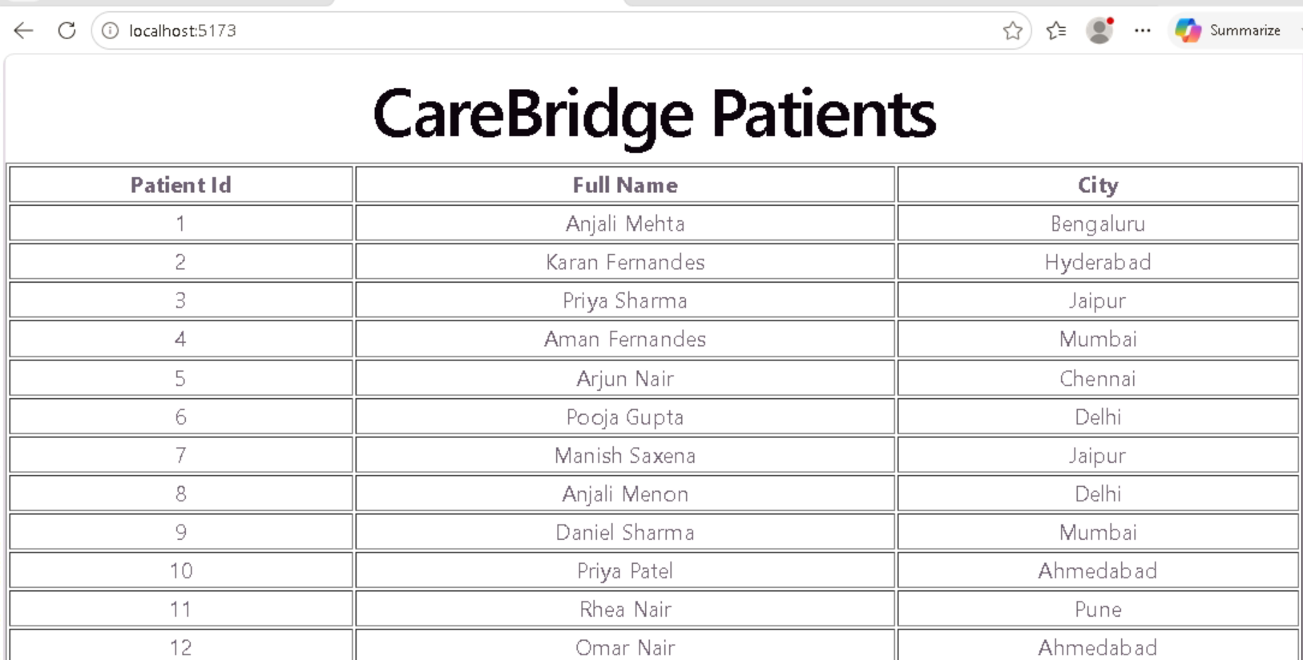

The Journey of a Single Request

1. User opens browser.
2. Vue page loads.
3. Vue sends HTTP request to API.
4. ASP.NET Core receives request.
5. API executes EF Core query.
6. EF Core generates SQL.
7. SQL Server returns rows.
8. API converts rows into JSON.
9. Vue receives JSON.
10. Browser displays data.

This entire process usually happens in less than one second.
TODAY'S ACHIEVEMENTS

✓ Connected C# to SQL Server
✓ Built EF Core model classes
✓ Created a DbContext
✓ Reverse engineered an existing database
✓ Performed CRUD operations
✓ Written LINQ queries
✓ Built a menu-driven healthcare application
✓ Built a REST API
✓ Tested APIs using Swagger
✓ Connected a Vue.js frontend
✓ Displayed live patient data from SQL Server

You have completed a full-stack data flow:

Browser
↓
Vue.js
↓
ASP.NET Core API
↓
EF Core
↓
SQL Server

Reflection
THINK ABOUT IT

1. What happens if SQL Server is stopped?
2. What happens if the API is stopped?
3. What happens if Vue is stopped?
4. Why does the browser never talk directly to SQL Server?
5. Why do we use an API layer?

Challenge: Add Search By City
Modify: /api/patients
to: /api/patients/chennai
and return only Chennai patients.

Then modify Vue to show only Chennai patients.
"I changed the backend, the frontend updated, and the data changed."

